4th October, 2020

Dear Sir,

I am contacting you after seeing your job advertisement from BDJOBS.COM. My interest in this position stems from my belief that I have the right combination of relevant staff experience and communication skills, which makes me a great candidate.

I consider myself to be a dedicated and dependable individual who possesses excellent verbal and written communication skills. I feel that a relationship with your company would be mutually beneficial, as my educational background, HR experience, and qualifications would make me a perfect fit for your Human Resources position. This opportunity would also allow me to refine my skills in a new working environment.

In closing, I would like to thank you for your time and attention and I hope to have the opportunity to discuss this job with you.

Sincerely,
MOHAMMAD SAIFUR RAHMAN

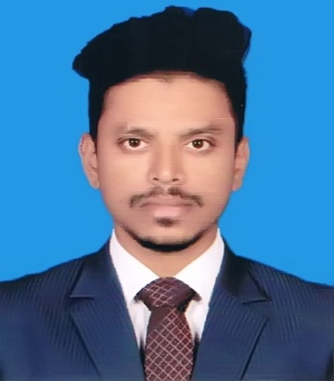
Mohammad Saifur Rahman

Mobile: 01722-284105

Email: saif.rahman06@gmail.com

saif.tod@amangroupbd.com
House no-245, Road-17, Block-N, Banasree, Dhaka

Career Objective

A position where proven my Human Recourse Management skills could be utilized to achieve the organizational goals and as well as develop my career.

Education

Post Graduate Diploma (PGD)
Bangladesh Institute of Management (BIM)
- Passing Year : 2020
- Major : PGDHRM
- Result : 3.00

Masters of Business Administration (MBA)
Independent University Bangladesh (IUB)
- Passing Year : 2018
- Major : Human Resource Management
- Result : 3.04

Masters of Business Studies (MBS)
National University, Bangladesh
- Passing Year : 2013
- Group : Management
- Result : Second Class
- Institute : Tejgaon College

Bachelor of Business Studies (BBS)
National University, Bangladesh
- Passing Year : 2012
- Group : Management
- Result : Second Class
- Institute : Tejgaon College

Higher Secondary Certificate (HSC)
- Passing Year : 2008
- Group : Business Studies
- Result : 2.70
- Institute : Urea Sar karkhana College
- Board : Dhaka

Secondary School Certificate (SSC)
- Passing Year : 2006
- Group : Business Studies
- Result : 3.25
- Institute : Urea Sar karkhana High School
- Board : Dhaka.

Experience

- Jr. Officer in Human Resource Department at AMAN Group Ltd. ( April 15th 2019 to Present)
- Major Responsibilities & Duties:

- Coordination and communicate in recruitment & selection process.
- Arrange & conduct employee induction program of newly hired employees.
- Coordinate & arrange training program including preparation of monthly training schedule.
- Collect training’s participant list from various department.
- Assist in conducting Training Need Analysis (TNA) to identify required intervention as needed.
Soft Skill Training

I have also completed some soft skills training which is under below:

Team Building
Business Communication
Professionalism at Workplace
Language Proficiency

Language | Speaking | Writing | Reading | Listening
Bangla | Excellent | Excellent | Excellent | Excellent
English | Well | Well | Well | Well

IT Skills

- Working knowledge on Microsoft Office (Word, Excel, PowerPoint)
Interests and Hobbies

Watching Sports, Listening Music, Reading book and Photography.

Personal Attributes

- Positive minded, self-confident and Friendly.
- Ability to learn and understand the new things quickly.
- Good Communication skills.
- Can work under stress and pressure.
- Love to accept responsibilities and getting them accomplished.
Personal Details

Name : Mohammad Saifur Rahman
Father’s Name : Md. Muzibur Rahman
Mother’s Name : Nasima Akter
Date of Birth : November 30, 1991.
Religion : Islam
Nationality : Bangladeshi (by birth)
Marital Status : Single
Permanent Address : House no-245, Road-17, Block-N, Banasree.

Reference

Md. Hanifur Rahman Zakir Hossain Parvaz
GM- HR Asst. Manager- Training & Development.
Cell: 01711488349 Cell: 01741728939
Email- hunrebu@yahoo.com E-mail- mzhparvaz@yahoo.com
Corporate Head Office Corporate Head Office
AMAN Group Ltd AMAN Group Ltd
2 Ishakha Avenue, Sector-6, 2 Ishakha Avenue, Sector-6,
Uttara, Dhaka-1230 Uttara, Dhaka-1230

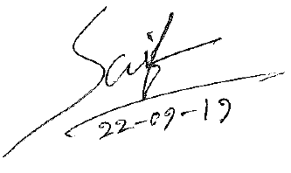

Date: 4th October, 2020 Mohammad Saifur Rahman

